**Form Recognizer API**

Form Recognizer API helps you to analyze and extract data from form/tabular kind of images/pdf by consuming the Azure Form Recognizer service’s pre-built form processing models. Here we make use of the formInfo resource deployed on the Azure platform. With this API you can identify and extract text, key/value pairs, selection marks, tables, and structure from your documents—it outputs structured data that includes the relationships in the original file, bounding boxes, confidence and more. This saves on heavy manual intervention or extensive data science expertise.

**Enpoints-**

**/invoice** – Returns the analyzed invoice page image/pdf in json format. [Click here](http://142.93.10.50:3000/docs/#/default/post_invoice)

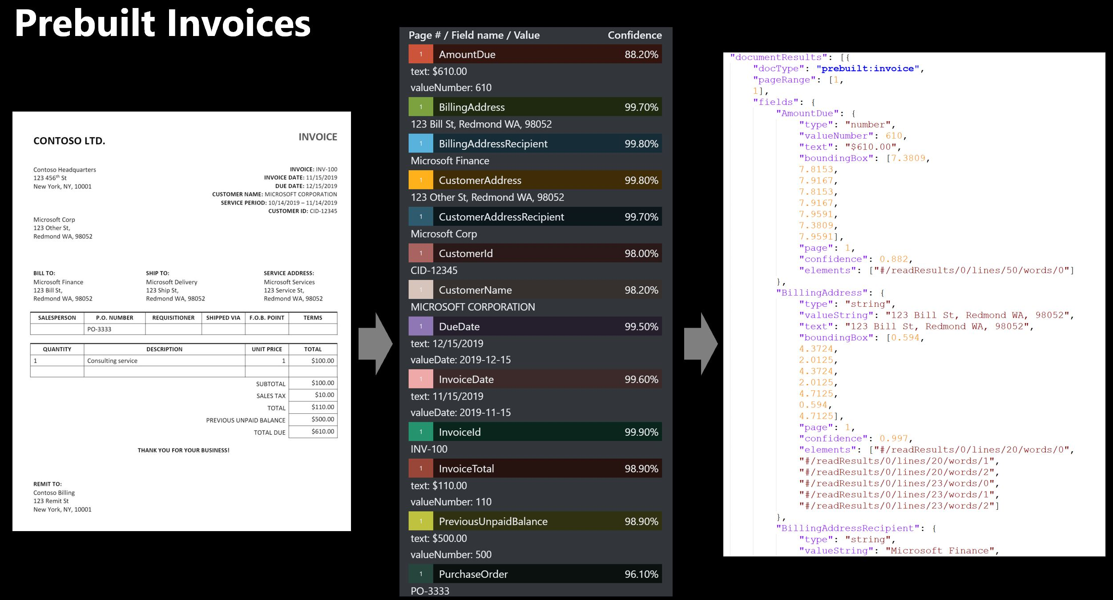

**/businessCard** – Returns the analyzed Business Card image/pdf in json format [Click Here](http://142.93.10.50:3000/docs/#/default/post_businessCard)

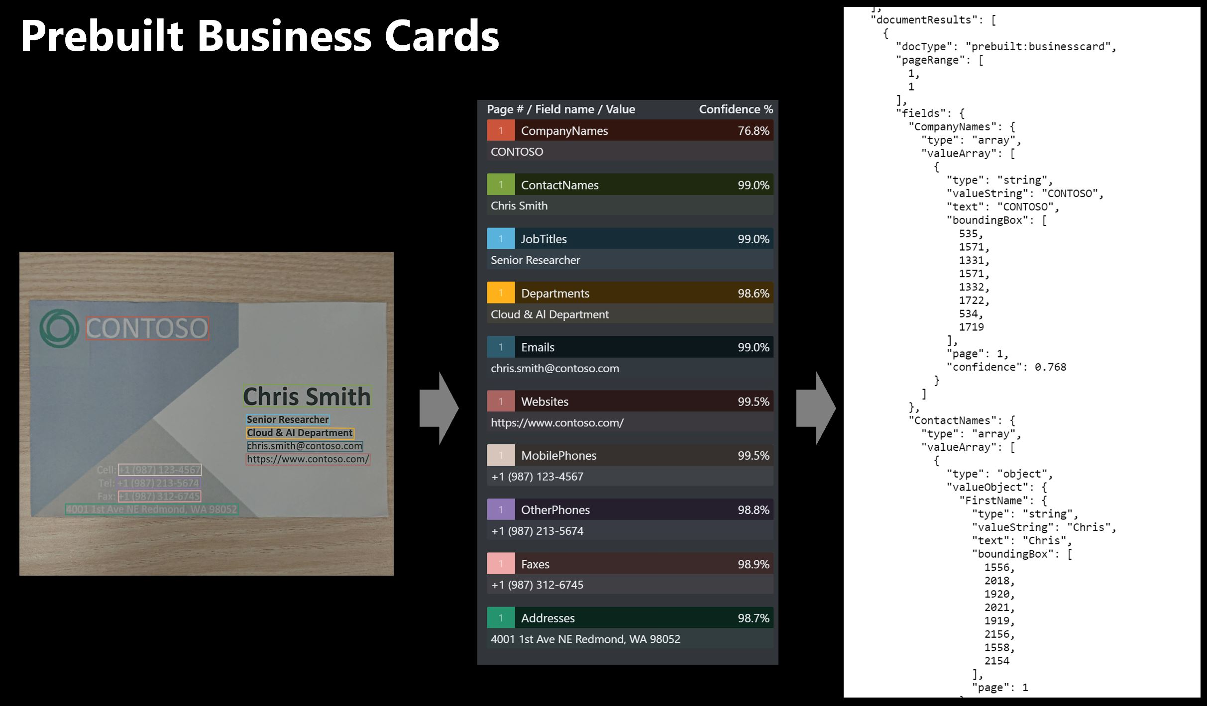

**/tableInfo** – Returns the analyzed Table image/pdf in json format [Click here](http://142.93.10.50:3000/docs/#/default/post_tableInfo)

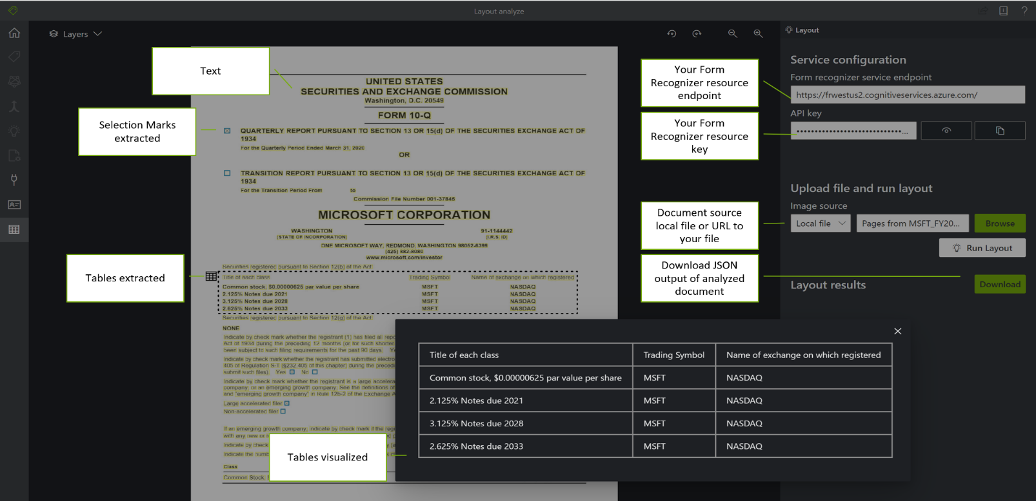

**/receipts** - Returns the analyzed receipt page image/pdf in json format [Click Here](http://142.93.10.50:3000/docs/#/default/post_receipt)

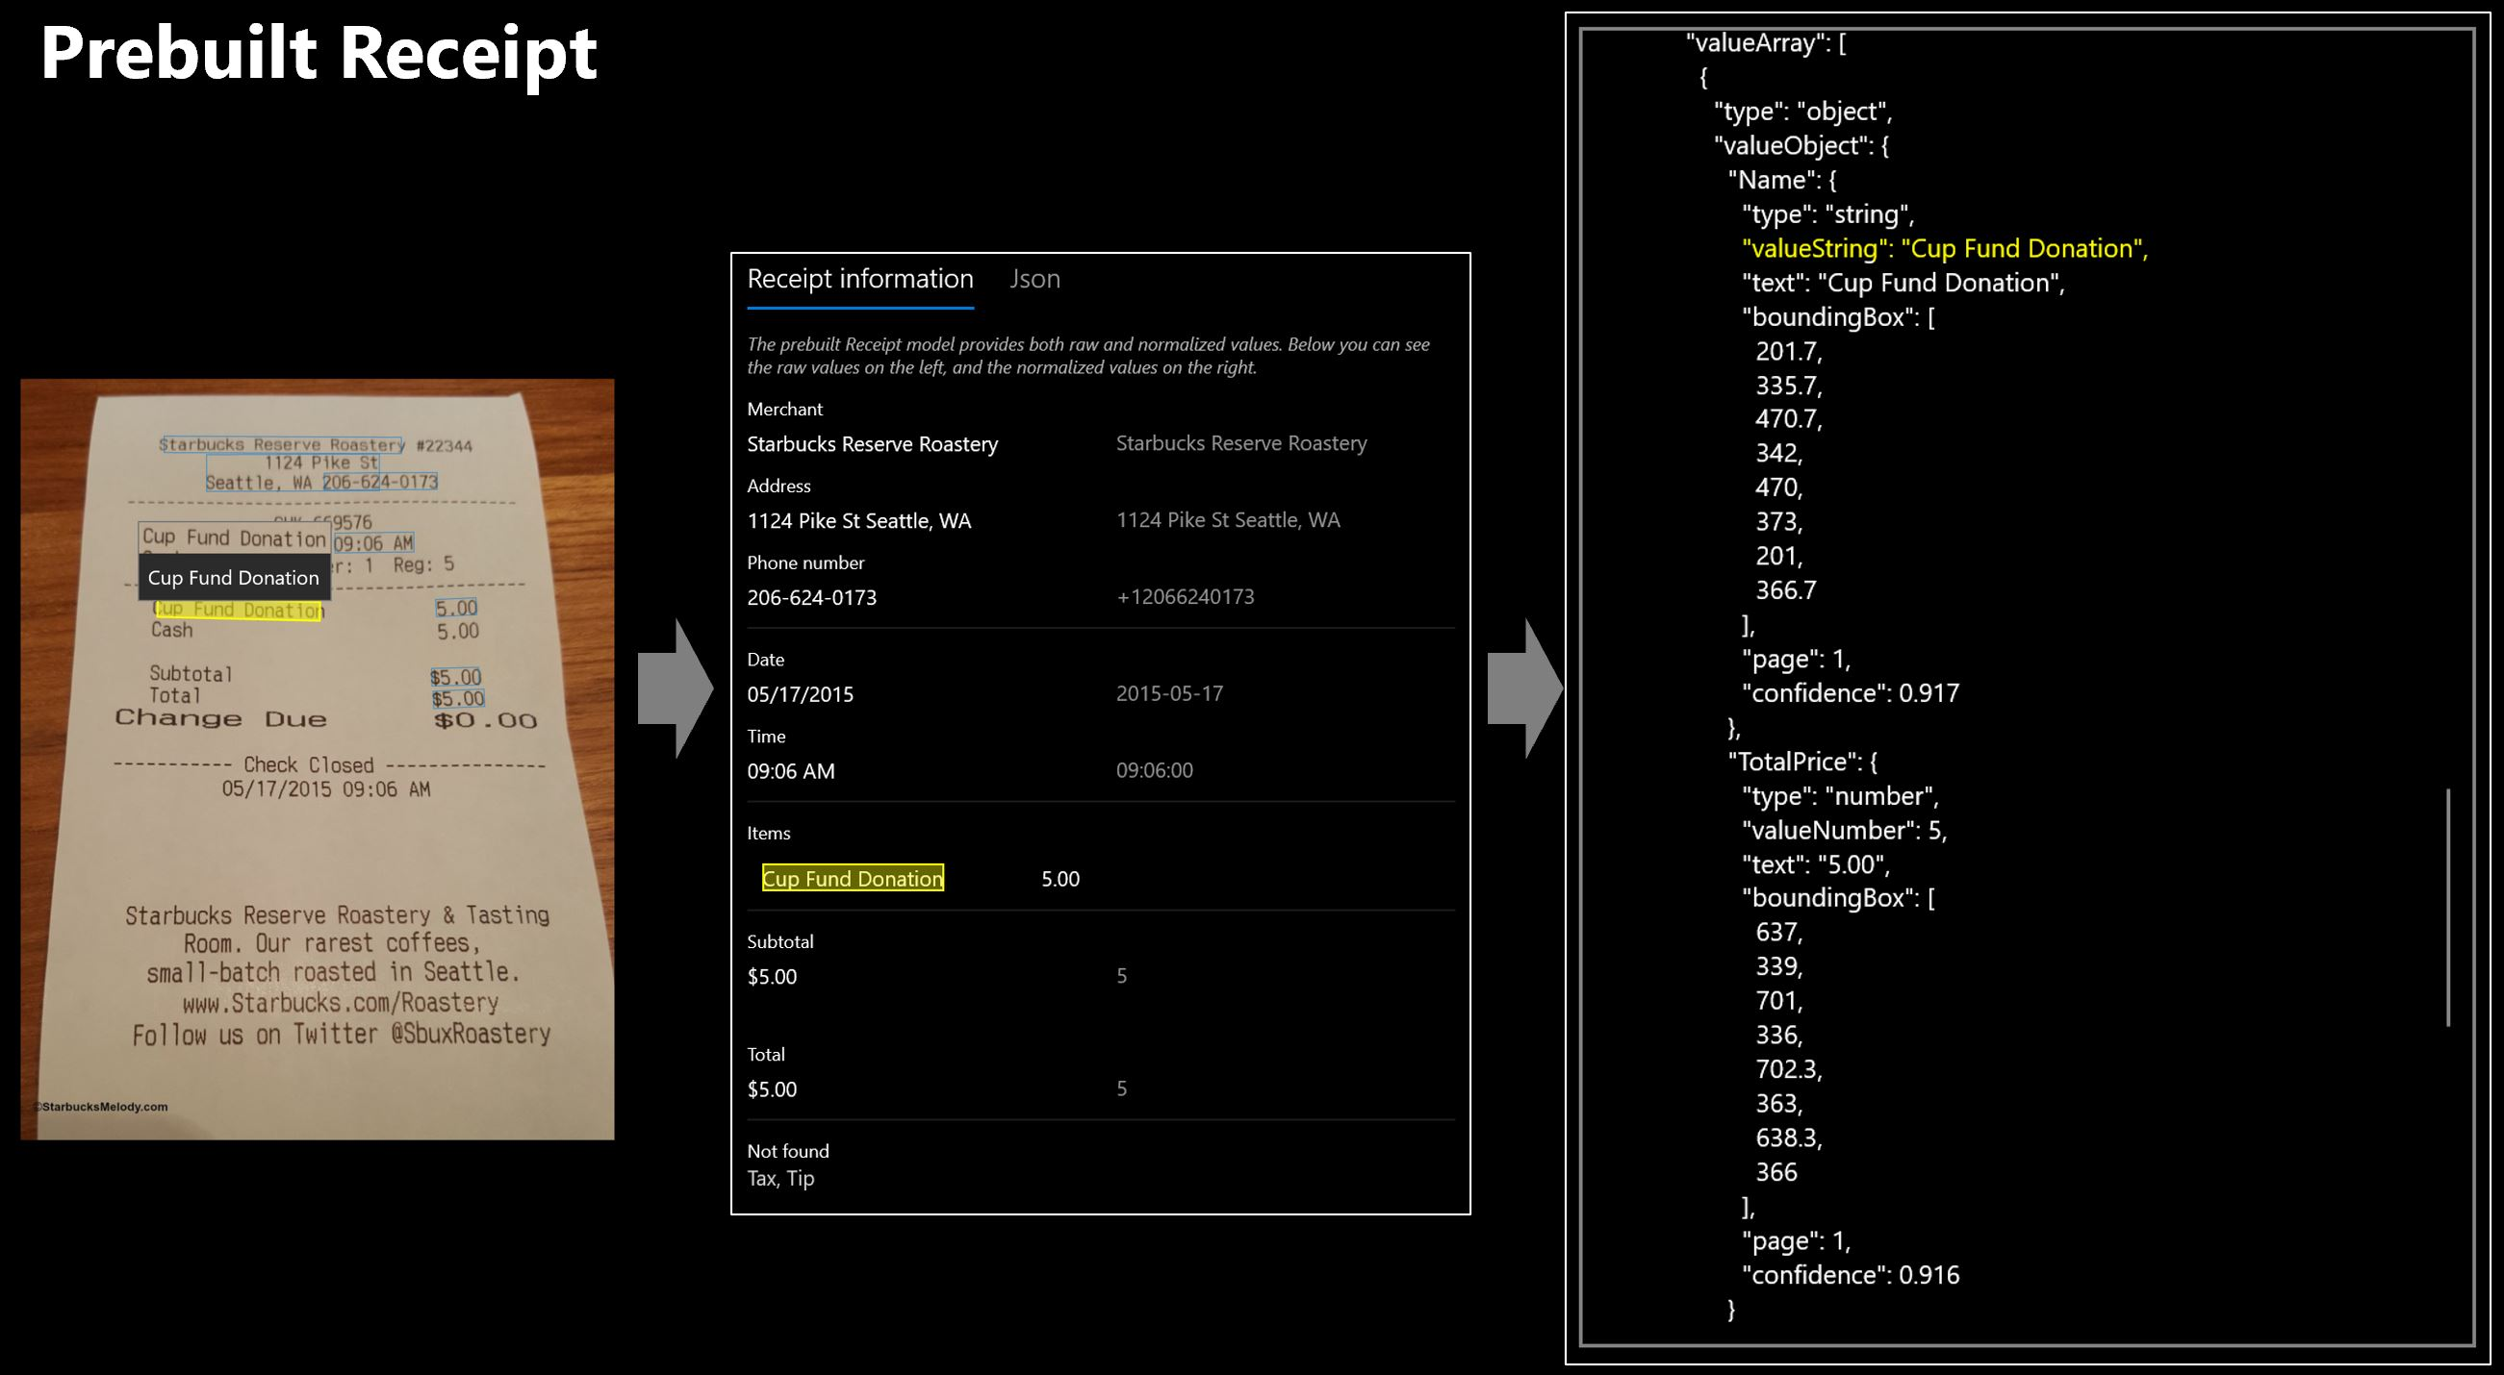

**Input Types: (in body)**

Image in the form of jpeg, jpg, pdf, png.(formReader.js ) and URL(formReaderURL.js)

**Header:**

    'Content-Type': image/jpeg, image/jpg, application/pdf, image/png, application/json

    'Ocp-Apim-Subscription-Key': apiKey,

**Params:**

    "includeTextDetails": boolean, *to see the results

    "locale": location_string *location of resource

**Output:**

Analyzed/ Extracted data from the image in JSON format. Ouput is present in the "readResults" node

**Possible Error codes:**

 200:  Analyed image

 400:  Analysis failed

 401:  Fail to get the results

 500: Invalid path or unsupported Image

 501: no path provided

**Following Edge Cases are Handled:**

1. No image path provided
2. Invalid Image path- ie. cannot load the image
3. Invalid or not supported extension
4. If the analysis cannot happen for the given image
5. The get url (where results are stored) doesn’t work

**Important points for different roles Consuming this API-**

**Developer:**

1. npm install – to install all dependencies
2. npm start – to start the API
3. visit, <http://142.93.10.50:3000/docs/> to test
4. two axios call- one to post the image to provide it to the in-built model. This on the backend analyzes the image and returns a url from where we can see the results.
5. The get axios call actually returns the analyzed/ extracted results in JSON fromat by hitting the url provided by the previous post call

**System Integrator:**

1. Fast, efficient and robust API to analyze/extract data from images of the form- receipts, invoices, Business Cards and Tabular.
2. 2-3 step configuration and no high-end technology dependency
3. Azure cloud support available
4. Can customize for our own data by utilizing Azures ML models
5. Firt version can be deployed as early as in 2 weeks

**Business Manager:**

1. First 500 transactions free
2. Low Storage and Maintainability Cost